**(43) Industry**

Industries:

Factor affecting the location of industries are ;

1. Raw materials ex. Iron and steel industries is raw materials-based industries
2. Climate: raise of Bangalore as IT HUB Has been possible for climate. There is cotton industry due to humid climate. Establishment of cotton industry that cotton fiber to threads required the humid climate as cotton thread can break in the dry climate.
3. Connectivity: accessibility to railways road, roadways to reduce the transportation cause.
4. availability of water and other resources.
5. Government supports and policies in the from of tax subsidies
6. Research and development. Ex. Change in the technology broght about the change in the location of industry ex iron and steel industry
7. Other factors like governance labor laws availability of power, agglomeration benefit(raw material of one is finish product of another ).
8. Market and capital availability.

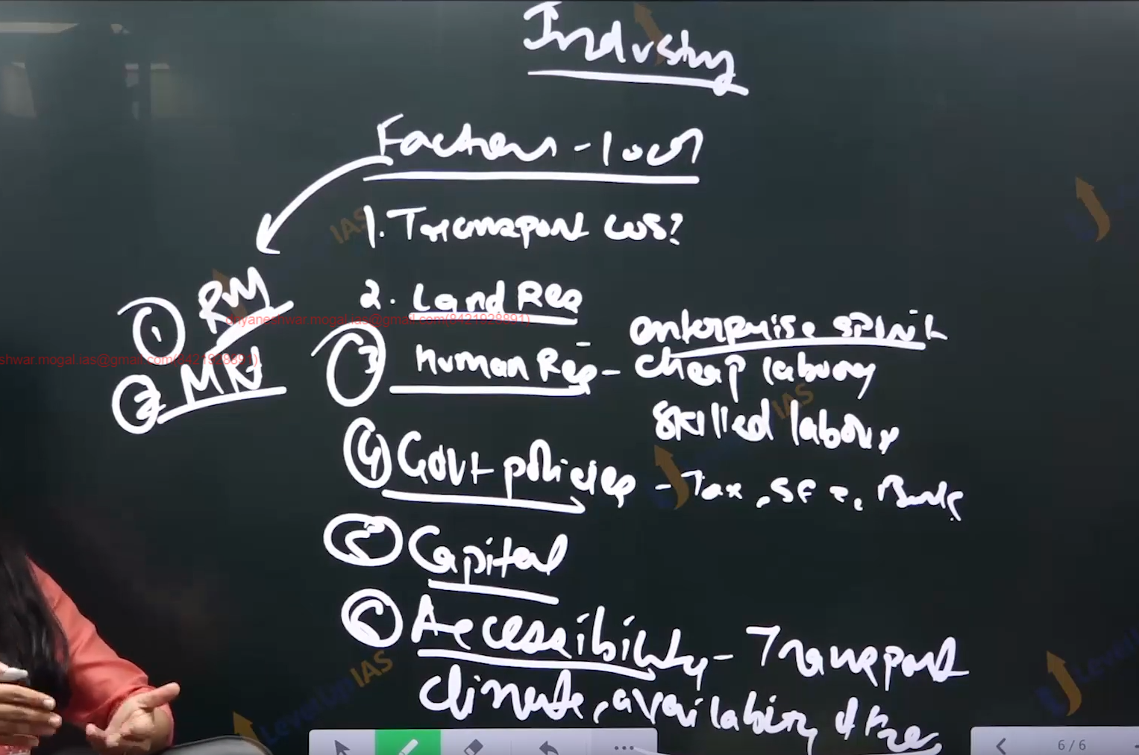

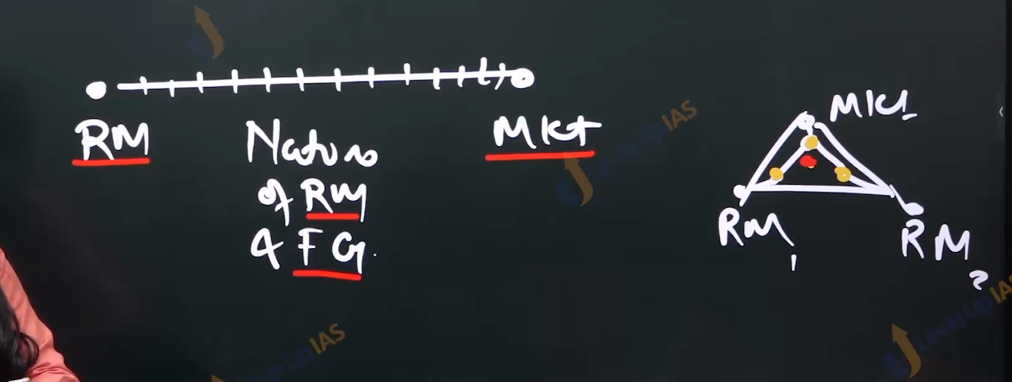

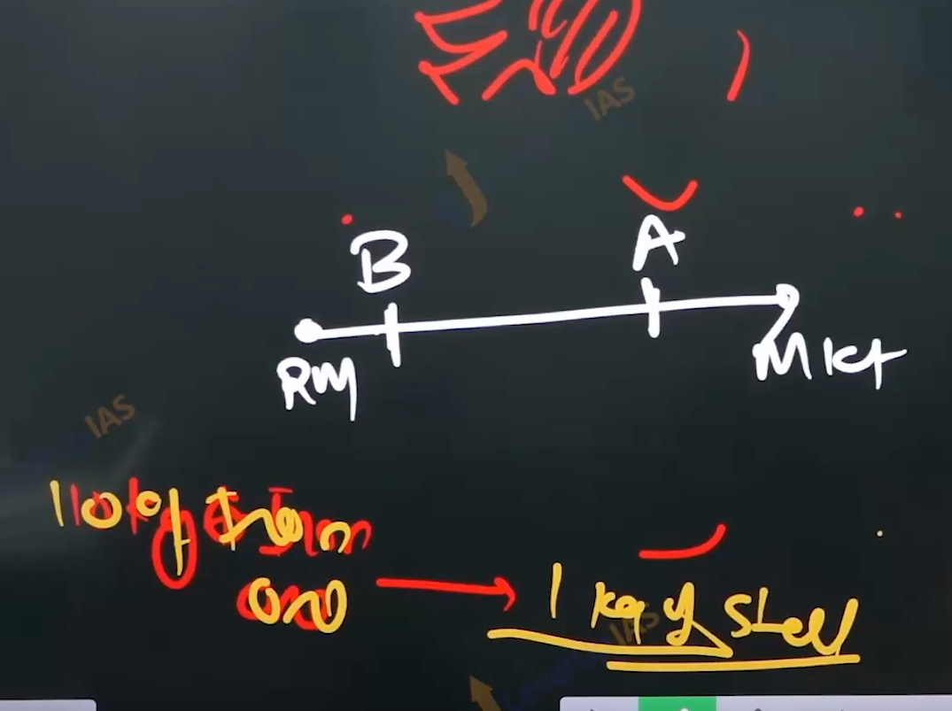

Cotton Industries:

1. The two main dominating factors in the establishment of industries are raw material and market.
2. Case 1. When the weight of raw material is more than the weight of finish goods that is industry is weight losing industry then the industries is established near the raw material. Ex iron and steel industries, bauxite refinery, electricity, sugar industries.
3. Case 2. When the weight of finish product is more than that of raw materials that is weight gaining industries that industries is established near the market center to has to reduce the traspotation cost. Automobile industries. Ex royal Enfield
4. Case 3 : when the weight of raw materials is same as that of finish goods such industry is pure industry It can establish any where between raw materials and market, however the industries are established in the market center due to fulfil of market and other benefit. Like capital availability and government support. Infrastructure accessibility. Cotton industries, jute industries.

Value chain in the cotton industries:

1. Cotton ball -> fiber, tread, fabric, cotton garment.
2. Boll to fiber, threads industries are near the raw material.
3. Thread to frabic, pure industries near the raw material and maket.
4. One that is fabic to garment : there is strong pull of maket and cheep labor.
5. cotton

cotton industry in the India

1. Production of cotton is predominantly in the western part of Maharashtra and Gujarat, black cotton soil , regular soil, therefore the western state had a advantage for the location of cotton industries.
2. Mumbai is known as cotton Polites of India due to availability of raw materials, humid climate being the prozximity of ports, nearness of the water bodies, mitti river, viability of electricity, tata hydroelectric power. Cheap labor nearest to market center and capital availability however the overtime Mumbai developed the disadvantages high rents population and labor strikes, therefore industries shifted to Ahmedabad and Surat region refers as Manchester of India.
3. As this is same industries advantages.

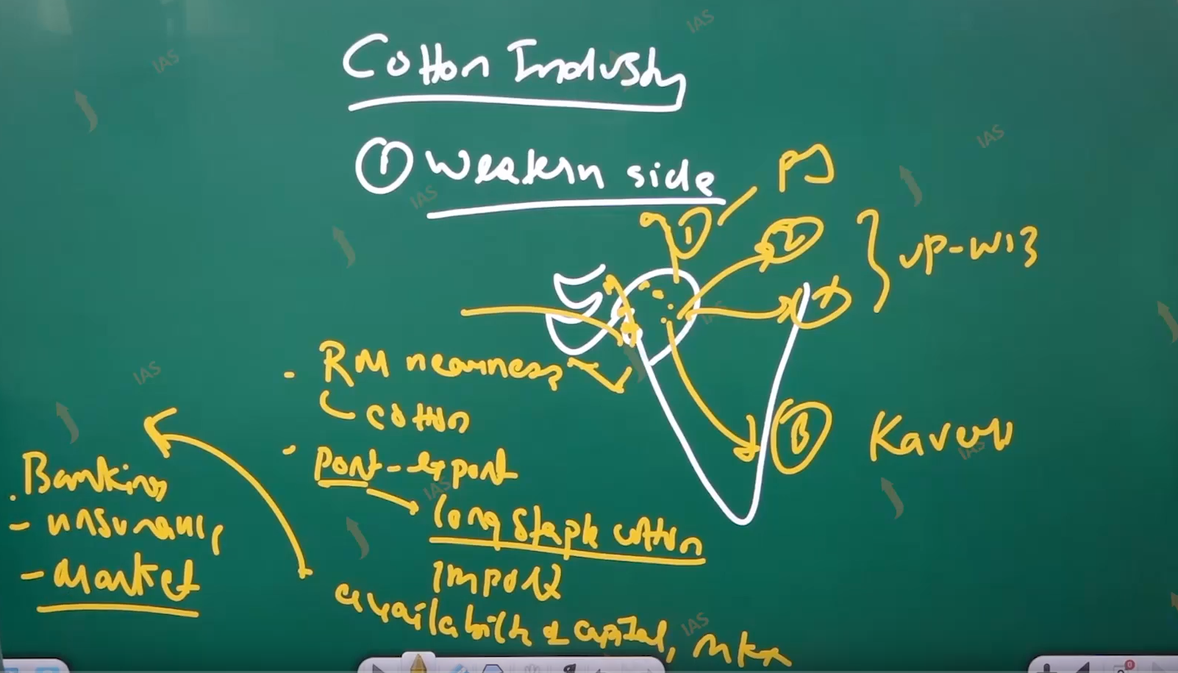

Shift of industries:

1. The Shift in the industries from the western section towards
   1. Panjab and the Green revolution area.
   2. Kanpur and UP Region and southern India.
2. Shift towards Panjab it is market-oriented location but has the advantage of availability of raw materials. The availability of irrigation facilities facilitates the growth of cotton crops. These industries have artificial humidifiers to manage the dry conditions to prevent the breaking of thread.
3. Panjab has the advantage of long staple cotton. Shift toward the Panjab.
4. Shift towards UP regions this is also market oriented regions to tap the market of north planes. This region has the advantage of availability of cheep and skilled labor. Chikankari of lakhanav.
5. There is goods availability of transport network and therefore cotton thread cotton threads are imported from the Panjab regions.
6. Similar conditions of west Bengal.
7. Shift towards southern region market-based location but has advantage of raw materials too.
8. The conditions that have facilitated the growth of cotton industries are huge demands availability hydroelectric power good railway connectivity and transportation line.

Jute industry:

1. Jute is pure industry neither weigh gaining nor losing, however the jute industry in India are near the raw material majorly. And also, in the place where there is availability of free-flowing water for the process of retting bleaching.
2. Reatting as process is labor intensive process labor intensive process therefore cheep labor becomes the important cratiea for the location of industry

Factor affecting the jute industries in india:

1. Raw materials center, free flowing water, cheap labor, market: jute industries are established around the jute consumption center and also near the port for tapping the export market.
2. And market in the form of agricultural operations: jute is used as merch.

Major important location of Jute industries.

1. Along the Hugli belt 90% indies are hear due to advantage like availability of raw material, Calcutta port, cheap labor, free flowing water, ex hugli river. Availability of goods transport network like rail,road waterways, and histroric advantage.
2. The first jute mill is established at rishra,

The important center todays are:

1. Rishra
2. Budge budge
3. Havada
4. Srirampur.
5. Out side the hugli belt in the darbhamga. Shamtipur, andra coast along the Guntur and kg delta.
6. Jute industry has suffer the setback after partitions as jute plantation were coasts to Bangladesh whereas industry remails in the west Bengal.
7. Other reason the jute industries suffer because of the alternative like pastic as packing material.

Silk industries:

1. It a piure industries therefore it can be easterbilshed anywhere between the raw materials and market. Howvery they are established near the raw materials. In proximity to silk can be easily precure.
2. One important concentration for the location of industry is availability of cheap labor
3. The importance of center are Karnataka regions are suitable of agroclimatic conditions for rearing of silk warm. Maberi tree and maberi verity of silk.
4. Advantages of Karnataka for silk Skilled labor, government polies, like national silk board which facilitates the research and development.
5. And industries were established duaring the world war 2. For making parachute.

The important locations are:

1. Mysore
2. Bangalore
3. Belgaum.
4. Etc.
5. Karnataka don’t have the well-developed market. And silk is sold to Varanasi Kanchi Puram, also to the external market.
6. West Bengal the industries are at the Murshidabad, Kolkata etc. The industries are based near the ports so as to export the products to Europe and America.
7. Raw materials can be precured from the Bihar Jharkhand and assam and the market pull and avilibility of capital and cheap labor can be tapped.
8. Some historical regions facilitated the development of industries.
9. Ex. Navvab of Bengal patronizes the silk artists.

Some other important locations are Bihar. Taser silk Bhagalpur ,

Andra Pradesh Tamilnadan, Kanchipuram.

Guwahati assam.

wool industries:

1. It is pure industry can be established market and raw materials.
2. The sources of raw materials is from the sheep and goats therefore they are precured from the Hilley area.
3. Some important location for the Punjab region, Ludhiana, Jalandhar, Amritsar, Chandigarh, dariwal.
4. The reasons are procurement of raw materials from Kashmir and Rajasthan as the wools are of pure quality as they are used for carpet and blanket.
5. Panjab has advantage of good market availability. Capital. Good connectivity via road and railways.
6. Maharashtra regions: along Mumbai and Thane. It markets based location
7. Taking advantage of port-based location, they import high quality wool and supply it to north plane.
8. Lakhanav UP regions. the important center are lakhanav, agra, Kanpur.
9. The raw materials are procured from the Rajasthan and JK
10. JK : The important center is Shree Nagar.
11. It is good quality wools used for making pashmina shorts.

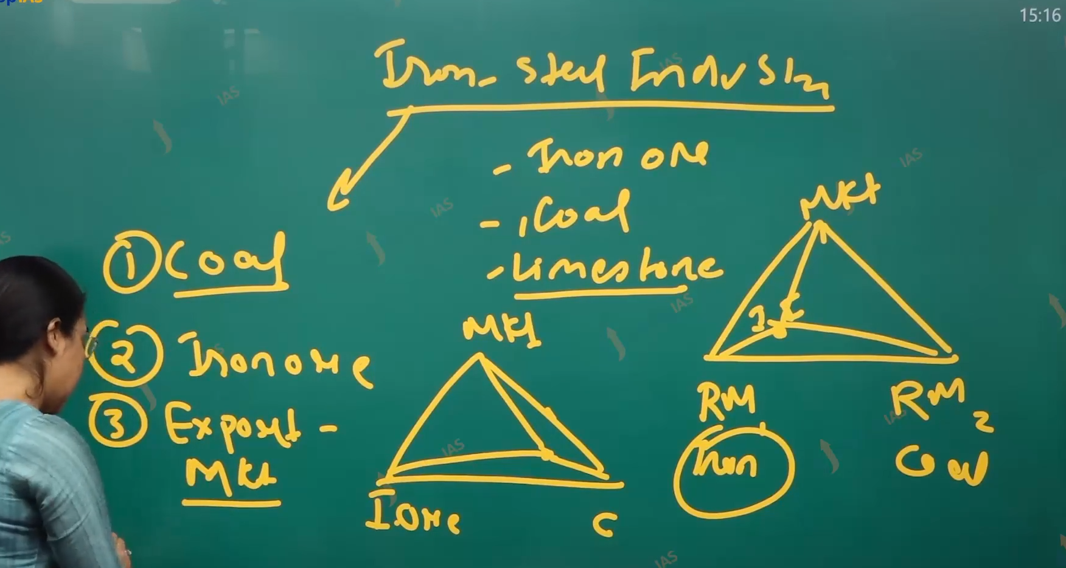

Iron and Steel industry:

1. It is a weight losing industry, therefore it is raw material industry oriented industry raw material need are iron ore coal, limestone( it is used as fluxing material).
2. Initially industry located near the coal center it seen along the choota Nagpur plateau ex buckaroo triangle. Coal is from Zaria coal fields, iron ore from Hazari bag and Ranchi. Power is from the DVC.
3. The market is industry around the Damodar valley corporation the buckaroo around the old technology.
4. In Bessemerize technology the 8 unit of coal plus 1 unit of iron ore was used to produce 1 unit of steel, therefore industries of buckaroo and Durgapur was designated as coal-based industries.
5. Industries are advantage of iron ore center along the choate Nagpur plateau.
6. Industries near the iron ore center.
7. These plants are relatively new where one unit of coal plus 2 units of iron ore is used to produce one unit of steel. ( it not depend on the coal for the energy needs therefore it reduced near the iron ore center.) such industries are seen in the baradravati, chieek magalu, shivmoga, belari , hosplate, tisco steel, plant .

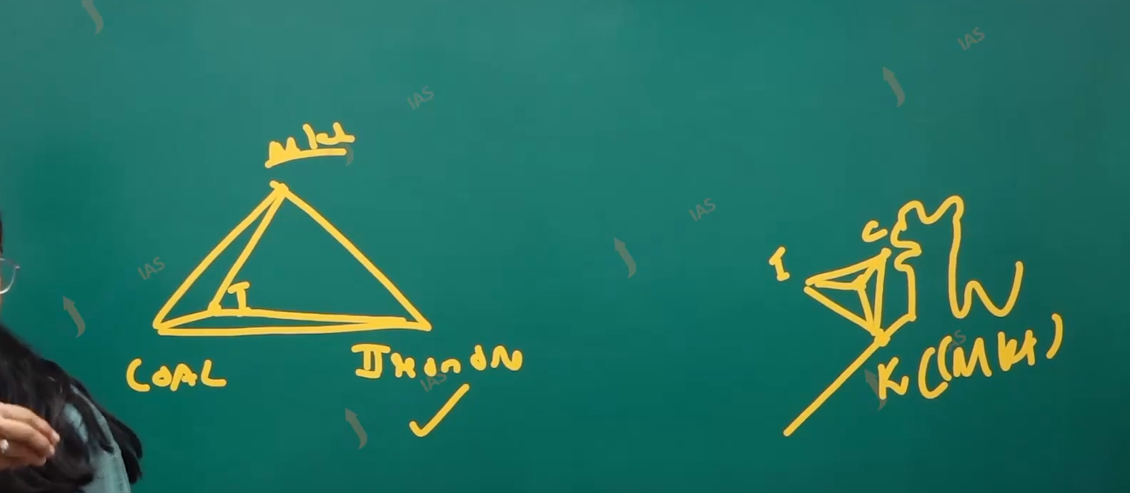



Case study TISCO:

1. Coal Is from the Zari coal fields, iron ore is from the guru maharani mine, limestone sis from the Odisha, water procurement, Suvarna Rekha river, and market is Jamshedpur and Kolkata.
2. Near ports: iron and steel industries near Vishakhapatnam, where iron ore is taking from the Karnataka, coal is procured from Australia. To tab the export market of Japan.
3. Near the market center: scrap steel-based industries. They used scrap steel and therefore are footloose industries. They are established near the major urban center. Like indoor and Jabalpur, Bhopal, Nagpur, etc.

Aluminum industries:

1. It is a weight losing industry. and therefore, it is established near the raw material center the raw material needed are bauxite it primary ore of aluminum whereas the minor raw material are caustic soda. Bauxite -> alumina -> aluminum.
2. The location of aluminum industries is such that alumina refinery.
3. It involves the process of conversion of bauxite to alumina by removal of the waste. And hence the industries are established near the raw material.
4. Alumina to aluminum this process involves the process of electrolysis. And therefore, the institute was established near the energy resource center.
5. Ex Hindalco plant in the reincur UP. Bauxite is procured from the peninsular plateau due to hot and humid temperatures whereas energy is option from the sing Lori coal field and riband dams.

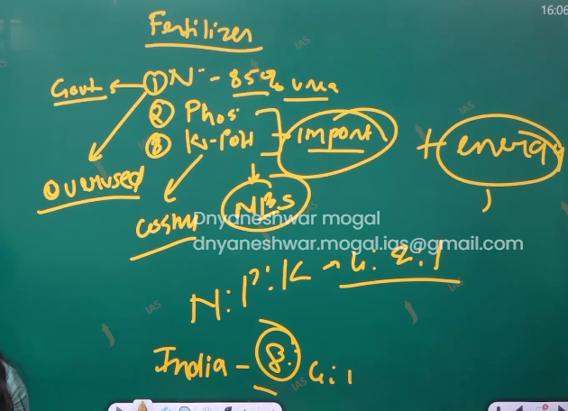

Fertilizer Industry:

1. The agrarian economy like India. Depends on the fertilizer for improving land productivity and boosting agricultural output. In order to fulfill the food security. India is among the top 3 producer of fertilizer.
2. In 1950 the food grain production was 50 metric ton while it has increased to 320 metric tons. Due to one of reason fertilizers.
3. :

History of fertilizer industry in India:

1. In 1950 and 60 India produce 2 types of fertilizer: ammonium sulphate and single super sulphate. Later on, with the modernization of the fertilizer sector the fertilizer producer are nitrogenous fertilizer.
2. Diammonium phosphate and potash-based fertilizer.
3. Urea amount to 80% from eh nitrogenous fertilizer. DAP amounts to greater than 60 % phosphate based fertilizer. Nearly 100 potash in imported.

Factor affecting the location of industry:

1. Raw materials is a factor. Much raw materials are imported. Therefore, industries are near the port
2. Energy needs: initially the fertilizer industry used naphtha which was also imported therefore industries located near the port.
3. Naphtha is liquid combustible hydrocarbons. However, with the energy diversification like used of HEP, gas, coal. The fertilizer plant also disperses. Ex. Establishment fertilizer plant in Namur Assam, which is a national gas based. Sindri in Jharkhand coal-based plant.
4. Fertilizer plant in the nagal, Panjab HEP based plant. Earlier the plant established near the port but later the fertilizer plant also found oil and gas pipeline and refinery center.
5. Ex. fertilizer plant along he Mathura Bathinda , Hazira. Bauroney.
6. Fertilizer plants have also been established in the market center that I near the agriculture fields. Some important center in Gujarat, kalon, Bharuch, Vadodara,
7. Tamilnadan: Coimbatore regions, Maharashtra : Bombay region.

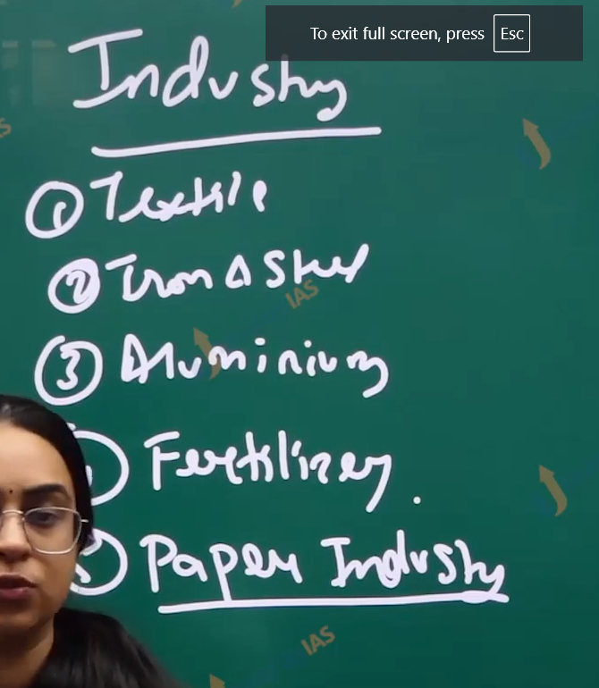

**(45) Industry-III**

Paper industry:

1. IT’s raw material-based industries. Raw material is obtaining from the forest. The majority of forest are tropical forest with problems like issue in the accessibility in the forest. hardwood therefore difficulted to cut, pulp quality is not as good compared to temperate forest.
2. Therefore the plaper industries in India used raw materials of sagbai grass, bamboo, and sugar cane residue. It seen that paper industries tens to agemate with the chemical industry.
3. Major Industrial center are kolkatta. Bamboo is precuted from the north easter regions. Historical advantage as development started during the British era high export becaused for nearness of port.
4. Power is precured from DVC. Important center are dumdum havada. Ranighang. West Bengal is largest producer.
5. Maharashtra: the important center are Mumbai , pune jalgoan, kahdala, raw material is precured from the sugarcane residue. Bagass, bamboo is obtained from the westen ghat. Mumbai obtain the plum from Europe for better quality of paper. Industries are also because of ready availability of major factor, capital market, port.

Q. discuss the factors, for the localization of manufacturing industries western side of India.

Intro:

Much of financial capital re accumulated near the Mumbai regions because of historical advantage which is trading center for ECI and British power. It is economical capital of India.

Westen regions standout in prominence due to present of cotton, paper, sugar, textile, automobile industries

Factor

1. Market access using port
2. Raw material of cotton due to black cotton soil, sugar cane, cotton, bamboo in the western ghat,
3. Due to high annual rainfall of western ghat from the average of India. The fauna of the region is prosperous. abundance amount of water can create the raw material easily.
4. Historical benefit: important trading center for EIC and other European traders.
5. Capital /and banking system availability.
6. Fraide equalization polity: of India government:
7. Government policy support: taking example of Tata nano factories in the west Bengal, due to protest factories shifted to the Gujarat regions. Land grant and taxation concessions, government subsides.
8. Due to the whole ecosystem of industries. New industries also set up here.
9. Cheap and skilled labor
10. Hinterland connectivity:
11. Entrepreneurship
12. Climate:
13. Investments:
14. Infrastructure developments:
15. Frist mover advantage for the film industries the dada saheb Phalke started producing the films. And generated the new industries

Example is must in the answer.

Port Mundra port,

Skilled workforce pune is called as oxford of east because of better education facilities and training facilities.

infrac

conclusion:

we should work on the decentralization of industries by these. Help equitable development of all locations

Q. Account for change in the special pattern of the coal industries world.

Coal is distributed in the world in Europe: Germany France US, Rasshiiya, pachora, maxco,kuznesk, asia. China xangi, inida jakahan,

Migration of indusies are taken place form northamer ical throuth china and india due to fallowing factor.

Cheap labor and cheap exploitation.

Demands of goods. Due to rising pollution

Decline in the traditional reserved especially among the Germanys

Rapid industrialization

Easy availability of transportation.

Discovery of new reserve: discovery of coal near the austrial along the easak river coal mine

Cheap labor.

Other industry

Pharmaceutical industry:

1. India is known as pharmacy of world, pharmaceutical produce include drugs medical devices Ayush produces. Antiretroviral drug, biochemical.

Factor affecting the raw materials:

1. Pharmaceutical industry need raw materials need the active pharmaceutical ingredients. (api) are generally imported therefore the industries are established near the port.
2. Pharmaceutical industries are capital insensitive and require the skilled labor therefore the industries are established near the market center.
3. Angulation benefits also affect the location of these industries. That is, they are established near the petrochemical industries as some bioproducts like jelly paraffin vax are used in the pharmaceutical industry.
4. The other factor are infrastructure and government polices, water and power availability and accessibility good network of transport and communication.
5. Some important center for pharmaceutical industries are Mumbai, surat, pune , Ahmedabad, Hyderabad, Himachal prades has badi and solan regions, Nahar Gadh , in Uttarakhand Dehradun Haridwar. Products are Ayush based products lots of government subsides have facilitated the development of industries

Q. What are the reasons behind concentration of pharmaceutical industries on the western side of India.

Q. Discuss the factors driving the growth of pharmaceutical industry as well as changes of faces to grow.

FACTor:

1. Life style diseases.
2. Average life span increased.
3. Government policy.
4. Export market.
5. Expanding market in the Japan and Europe.
6. Great export potations.
7. There is content production innovation and development of generic drugs which are cheep compare to patented drugs.
8. Government policy in the based on phyma sez.
9. Increase In the disease burden, due to climate change, pollution, etc. report global disease report.

Issue:

1. Shortage of API.
2. Lack of innovation.
3. Lack of quality control / and adequate regulations for pharma.
4. Lack of financial aid for research and development.

Challenges faced by the industries :

1. Pricing regulation by the DPCO. Drugs price control order, which compromise profitability of industries.
2. Intellectual property right
3. Quality control and compliance order has many lapse cup syrup incidence in Kazakhstan.
4. Lack of availability of skill work force.
5. Policy flips flop variation.

Auto mobile industries:

1. This industry is indication of economic progress of countries. It includes two three wheeler automobile industries.
2. Factor affecting automobile industries are raw materials iron and steel therefore industries are near the iron and steel industries.
3. Ex. Jamshedpur. Urban center market to access the market the industries are located in the urban center automobile are weight gaining industries therefore they are established near the market center.
4. Ex. Pune, Chanani
5. Port based location : industries tents to located near the port to tap the export market ex. Ahmedabad, Chennai royal enfild. Center. Marma Gao port Mangalore.
6. Government policy tax subsidies and SEZ.

Agro-based industry:

Sugarcane industries:

1. It weigh industry therefore the indies are established near the raw material center.
2. Industries established near the suggercane cultivation area. ex UP Bihar area.
3. The industrialies are near the Bhagalpur samatipur, payagraj, industries work best under coaportive sector both the famer and mill owner need the coporation of each other.
4. Onces the farmer cuts the suggercane famer need the asure buyer the sugger contain is drastically reduces within 48 hours. And therefer depends on mills.
5. Also mill are profitable only if it assured and regular suppy of sugger cane.
6. The main sugarcane are UP Bihar belt Maharashtra regions kaveri besin etc.
7. Important center : traditional belt UP Bihar region , reasion for this location of industries are good sugarcane supply. Large rivers therefore easy availably of water. availability of power, cheap labor.
8. However, industry is shifting from the traditional belt to Maharashtra regions in the Ahmednagar, Kolhapur, Solapur,
9. In Maharashtra farmer prefers to grow sugarcane because cottons are dicey crop
10. Also, in the Maharashtra their tropical verity of sugarcane which yield sucrose content and has longer duration of suitable conditions for the growth of sugarcane
11. Another shift has been witnessed towards Kaveri basin.
12. Reasons good irrigation facilities which facilitate the growth of sugarcane cultivation successfully co-operative and tropical verity of sugarcane.
13. There has been a shift towards the Panjab region due to shift in the sugarcane crop.

Q. why is automobile industries near the Jamshedpur even though it weight gaining industry: ?

Iron ore

Near the port.

Q. What are factor that influences the distribution of high-tech companies in India and what are the challenges faced by the companies?

High tech companies:

1. Electronic
2. Aviation
3. Space industries.
4. Medical devices.

High tech :

1. High tech refers to business that focus on capitalizing expances and profit potantional of technology innovative industries. Example electronic, aviation, medical devices.
2. Distribution of high tech companies include Bangalore, Hyderabad, Pune Ahmedabad, Delhi NCR, Chennai, Mumbai , Kolkata.
3. Factors affect into location of such industries:
   1. Infrastructure: it required robust infrastructure reliable power supply
   2. Internet connectivity.
   3. Modern office space.
   4. Bangalore electronic city. Provide dedicated space and state-of-the-art infrastructure.
   5. Skilled talent pulls: Bangalore is Silicon Valley has institute like Indian Institute of science, IIM BANGLORE.
   6. Connectivity: Hyderabad has internation connectivity it is preferred location for the high-tech companies
   7. Government policies: sez has led to development of technological industries in Pune.
   8. Agglomeration benefit: cities lie Bangalore, Hyderabad, Pune, Gurugram, Noida, has well established IT hub and technology parks that providing the networking opportunities. Shared resources.

Challenges faced by the industry:

1. Skilled gaps: especially in the emerging like artificial intelligence and machine learning. National employee report 2019 for engineers showed that 70 % are unfit to take any industries relevant job. In the knowledge economy.
2. Infrastructure constrains: India still faces infrastructure issue like power outage limited internet bandwidth, in adequate transport network. Regulatory frameworks are time consuming.
3. Obtaining the license permit and regulation is cumbersome affting the ease of doing business.
4. Competition is very high for India companies from the global giant like amazon and Samsung for Indian companies.
5. Problem intellectual property theft and cyber security. India is among top 5 counties affected by the cyber attracts.

Major industrial regions of India

1. Mumbai Pune regions:
2. Regions for development are historical advantage, cheap labor from the hinterland, port facilities for import export, good connectivity.
3. Some important centers are Mumbai, Pimpri, Nasik, manmade. Solapur. Ahamad Nagar.
4. Industries: textile, chemical, petrochemical, oil refinery, cheap,pharmacuitical, building, electronic, FPI, ( food processing industries)

Hugli industrial belt:

1. It extents along the river hugali it extents along the hugli the cetner are bugbug rishtra, titagard,kokata, belure, haldia.
2. Reasons for development are : easy availability of water, good road and railway connections, nearness to mineral hart choate Nagpur plateau, cheep labor from the UP, Bihar, and Jharkhand. Odisha.
3. Power from the DVC, And historical advantage (presidency).
4. Industry: cotton, paper, jute, silk, cotton, high tech industry, engineering, pharmaceutical petrochemicals,

Bangalore and Tamilnadan regions:

1. Cotton industries sugar mill paper industry cement, coibtur is know as Manchester of Tamilnadan.
2. High tech automobile,

Gujrat industrial regions.

1. The major industrial belt lies between Ahmedabad and Vadodara.
2. Industries are textile oil and gas refined cotton silk synthetic fibers. Petrochemical, food processing deary industry.
3. Important centers are Surat Jamnagar Rajkot, Bharuch, etc.

Chhota Nagpur industrial regions:

1. Iron and steel, industries, heavy engineering industries. Paper,
2. Center: Ranchi , dangad,Hajari bag ,shindri.

Vishakha pattona kutoon regions:

1. The industries are petrolimus refinery, iron and steel. Sugar, textile paper, fertilizer, cement,pharmacuticals , etc,
2. Major center : vishakhapattman, rajmundir, kunur, gunguntoor, vijaywada.

Gurugram, Delhi meerat industrial regions:

1. Industries: software industries, textile, sugar, chemical, paper, electronic, petrochemical at Mathura, lather
2. Center: Modi Nagar, Sonipat, Panipat, vallab Gard.

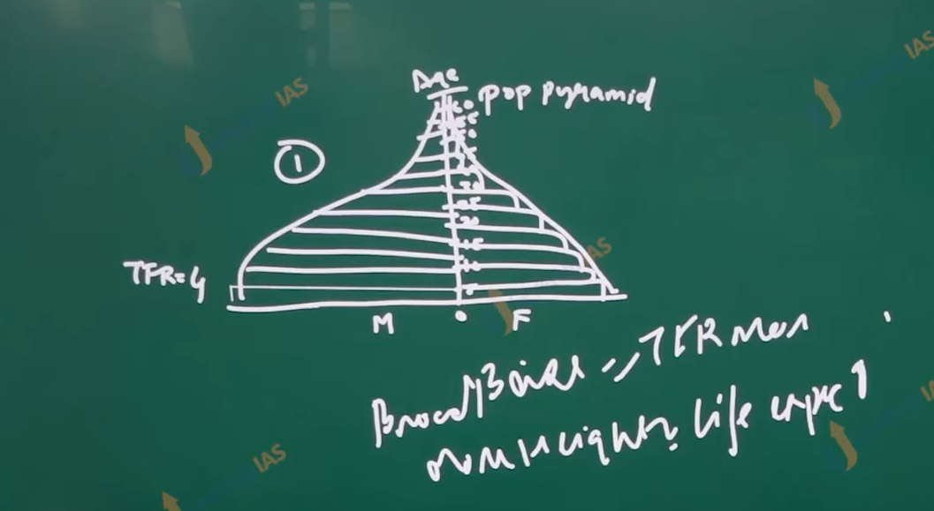

Kollam Thiruvananthapuram:

1. Major industrial: textile, sugar, rubber, glass, and fish prococing.
2. Important center : Kollam, Thiruvananthapuram, kochi ,Alappuzha

